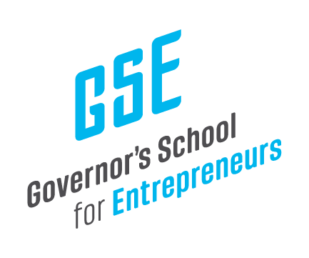

February 25, 2024

Mr. Jay Hartz
Legislative Research Commission Director
Sent Via Electronic Mail

Dear Mr. Hartz,

The Governor’s School for Entrepreneurs (GSE) is pleased to share our year-end financial reports for FY 2023 (October 2022 through September 2023), specifically our Audit and our Impact Report.

We have also provided the monthly financials for our First Quarter of FY 2024, covering the months of October, November, December 2023.

I welcome any questions or feedback on these reports.

Kind regards,

Anne

Anne Jewell
President & CEO
Governor’s School for Entrepreneurs

